LAB 10

EXERCISE 1 : Save five lines and read them back
File: FileIODemo.java
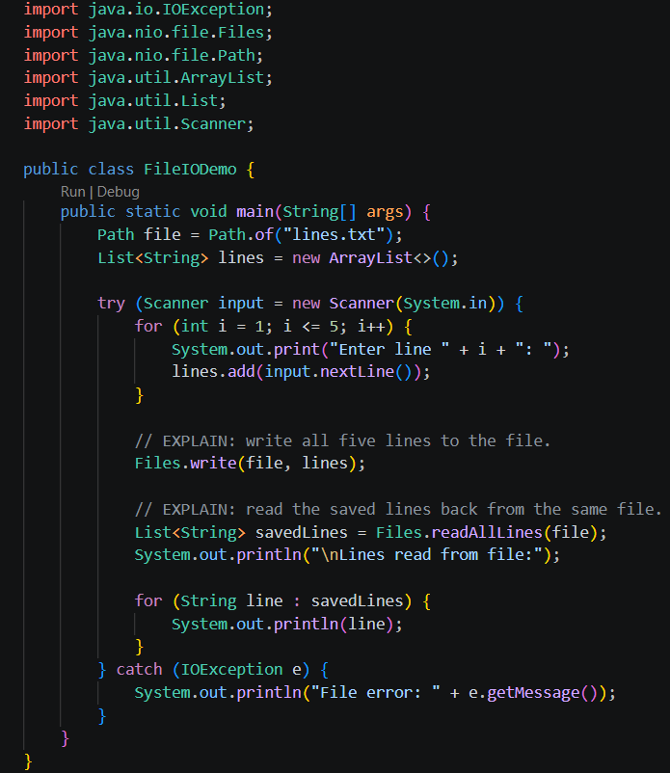

Output
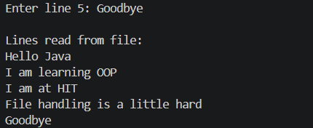

Also a txt file has appeared at the Lab 10 folder containg the the five lines from Hello Java to Goodbye

EXERCISE 2: Use Predicate and removeIf to remove even numbers
File: RemoveEvenDemo.java
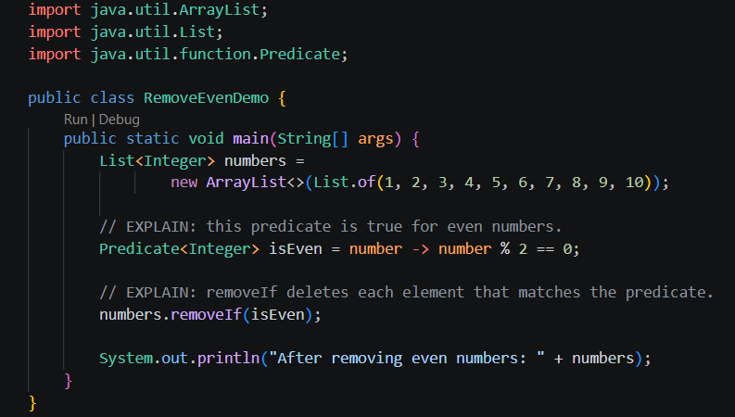

Output

EXERCISE 3: Count lines, words and characters in a text file
File: TextFileStats.java
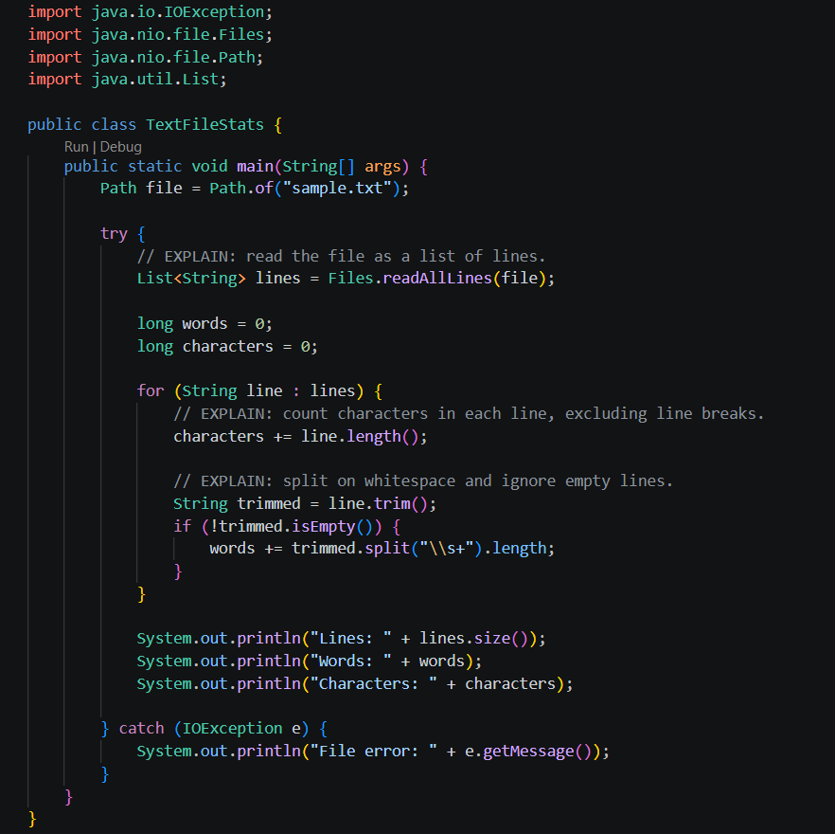
Output
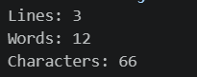

EXERCISE 4: Print students above the class average, alphabetically
File: StudentAverageDemo.java
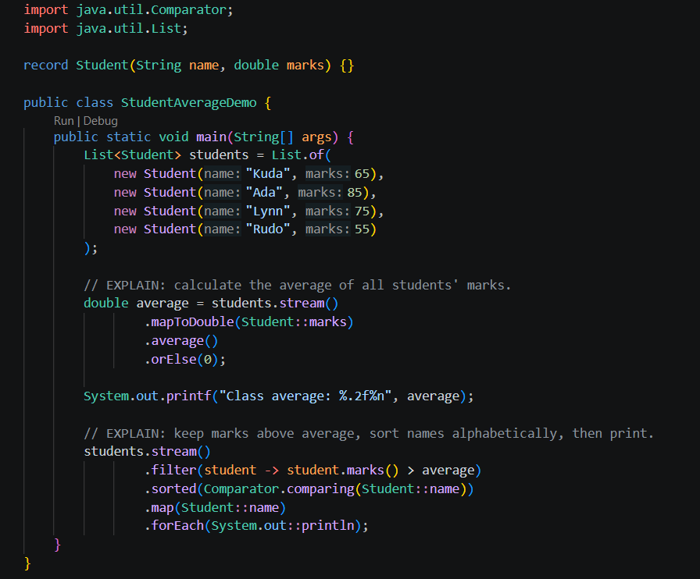
Output
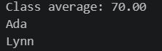

EXERCISE 5
File: LearnerReportDemo.java
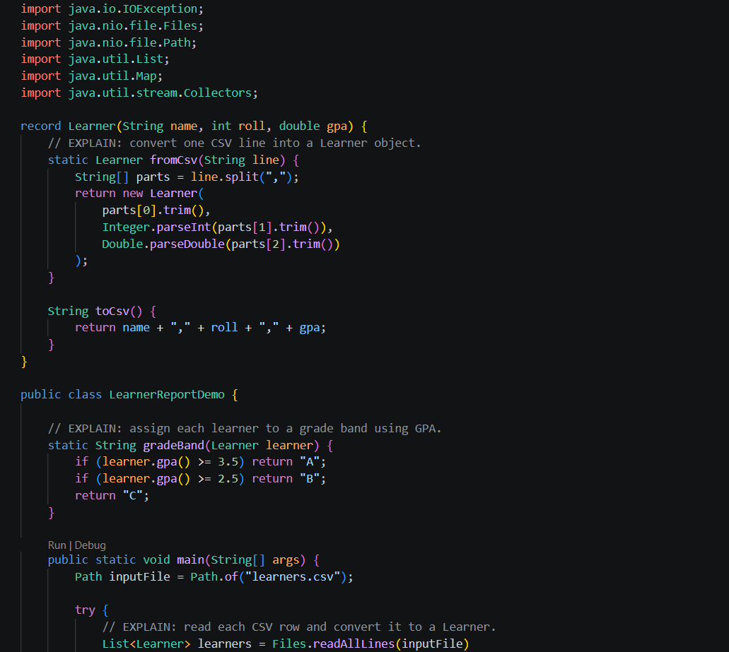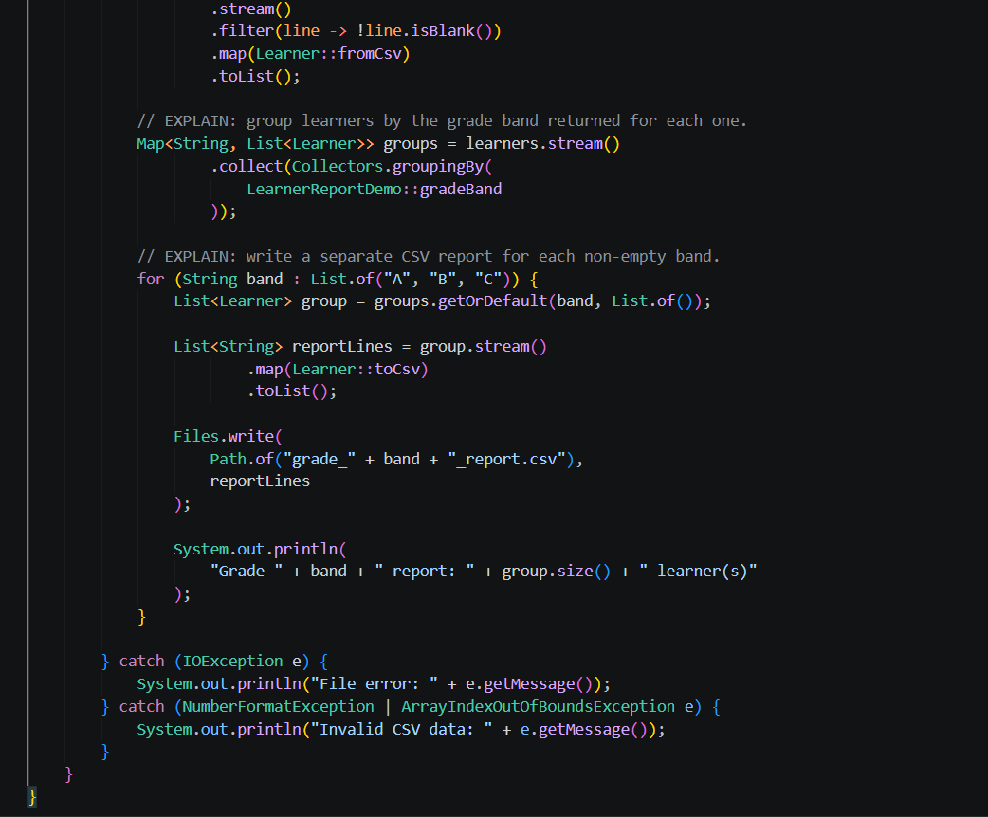
Output
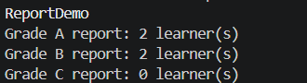
Also these csv files were automacillay created in the LAB 10 folder

